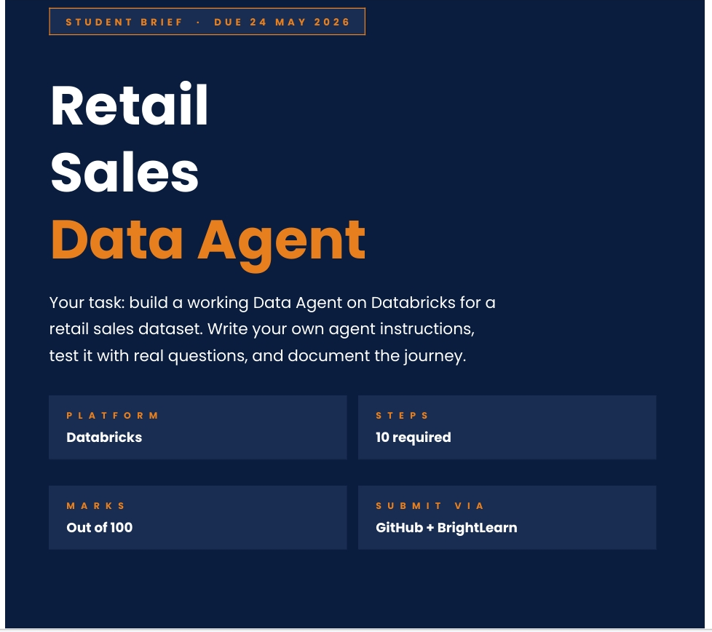
Name: Talifhani
Surname: Nemutudi
Date: 24.05.2026
APRIL INTAKE DATA ANALYSIS

Introduction
This project is about building a functional data agent that can analyse data, generate insights, and respond to user queries effectively. The assignment also involves uploading a data set on Sequel, Understanding the dataset and preparing the data for testing the agent’s ability to interpret and answer questions accurately, and evaluate the quality of the outputs produced.
Using SQL queries, various data analysis techniques such as aggregation, filtering, grouping, and statistical calculations. In addition, the assignment explores the strengths and limitations of the data agent by identifying loopholes, incorrect responses, unnecessary outputs, and areas where the agent may misinterpret user requests.
Objective
My overall aim in doing this assignment is to familiarise myself with how data bricks works ,how to prepare data for sequel and to understand how AI-driven data agents operate in practical environments, evaluate their reliability in supporting data-driven decision-making, and identify opportunities for improving the accuracy, relevance, and efficiency of automated data analysis systems.
Dataset description
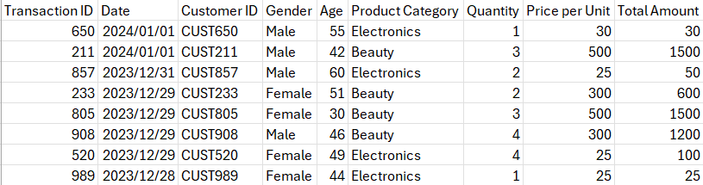
- The retail sales dataset is a set of data detailing Sales of a retail company
- The data is from 01/01/2023 till 01/01/2024
- The data is for the financial year end 2024
- The transaction ID represents a unique identifier assigned to each sale transition
- The column date shows the exact date that the transaction occurred
- Customer ID column details a unique identifier used to identify a customer
- The gender column shows the gender of the customer; this helps the customer to analyse whether its customer base is man or mainly women and it can help the company deep dive into how customer buying decisions are influenced
- Age column represent the age that the customer is, this can help the company check the demographics of its customers
- Product category column details the different divisions of products the retail company sells i.e. Beauty, electronics and clothing
- The quantity column represents the number of products the customer purchased per transaction
- The price per unit column shows how much each product cost this is the retail company cost price plus their mark up
- The total amount column is the quantity multiplied by price per unit, this details how much each transaction id made
- The retail sales dataset shows that the company generates $456,000 in total revenue
- The dataset details 1000 transactions from 1000 unique customers
- The data is complete and has no missing values
- The retail dataset shows that their oldest customer is 65 in the year 2023 Jan to 2024 Jan
- With their youngest customer in that same financial year end being 18

Question 1
Uploading the retail sales csv on Data bricks
You firstly need to create a Database to use the data tab-create table- upload file
How to create a database
- Click on + icon on data bricks under catalog tab
- Click create catalog
- Click on catalog name and name it dataagentR
- Click create @ bottom right
- Database will show under My organizations
- The database will have a default and information schema
Step 2
I created a schema in order for me to be able to upload retail sales dataset
How to create a schema
- With my cursor under database, I clicked on the top right on create schema
- Named my schema, SchemaR
- Clicked on create thereafter
Step 3
I downloaded the dataset from the bright learn portal onto my desktop, ensured that it is in the correct format which is csv
How to upload a table
- I clicked under database and selected my schema
- Then clicked on the top right on create then clicked table
- Clicked on browse ad selected the dataset under my desktop(retail_sales_dataset)
- I edited the table name and renamed it (retail_sales_dataset_2)
- Doubled checked the preview that it’s in the correct format (Table) once I was pleased with it

Screenshots

Dataset file

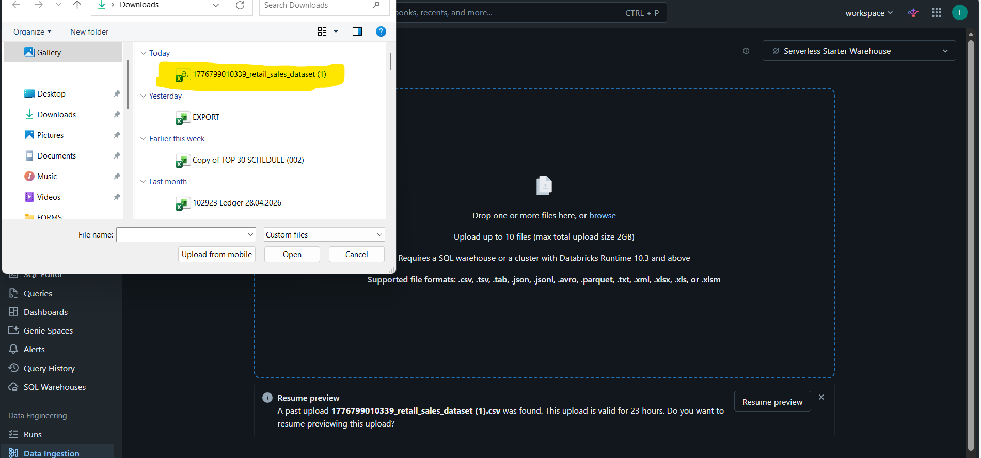

Preview
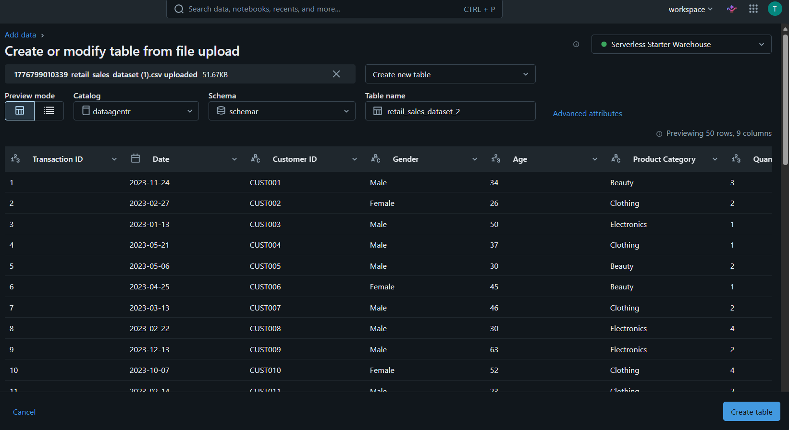

File location
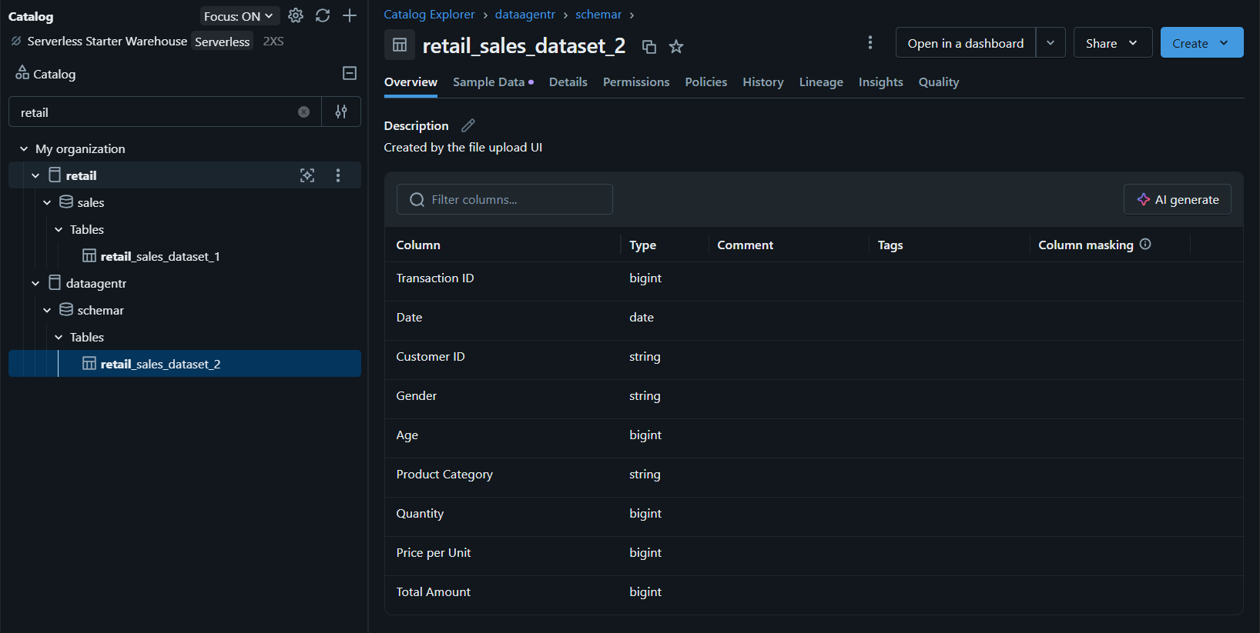

Question 2
Preview
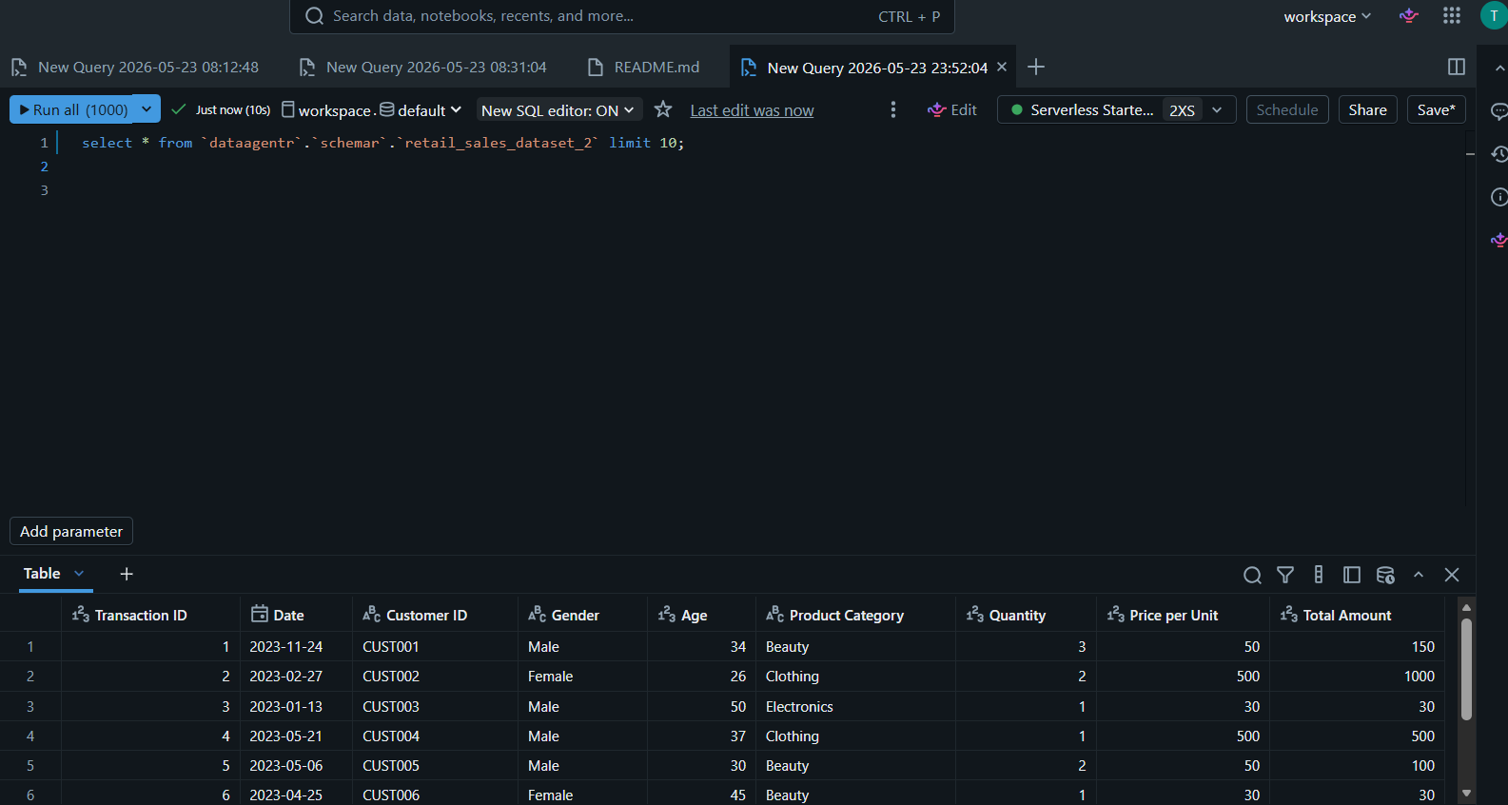

Columns
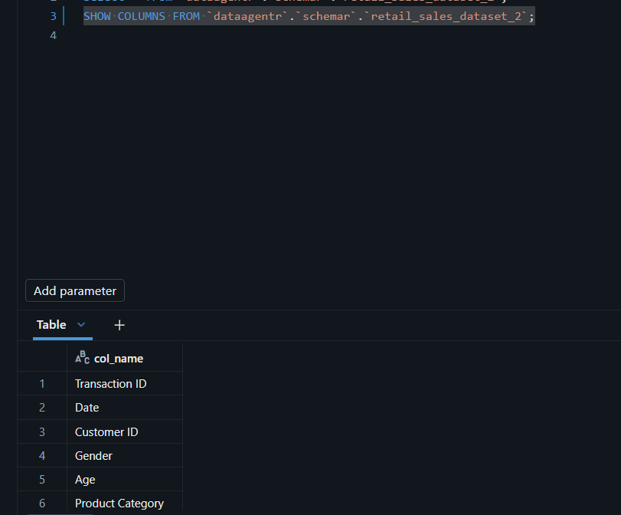
- Customer id; gender; age can be used for customer analysis
- Date, product category and transaction id can be used for product analysis
- Quantity, price per unit, total amount can be used for sales analysis

Summary stats
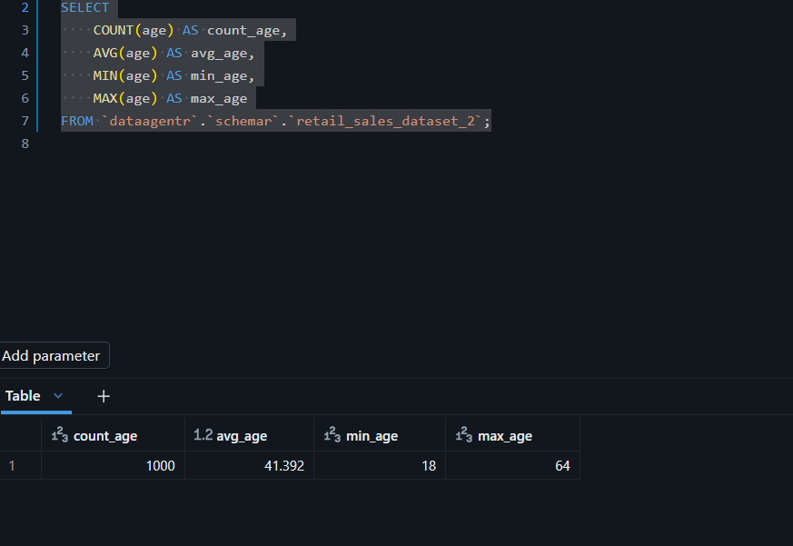

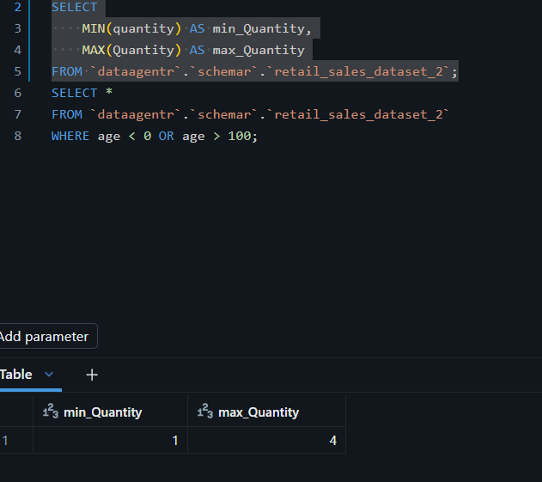

Question 3
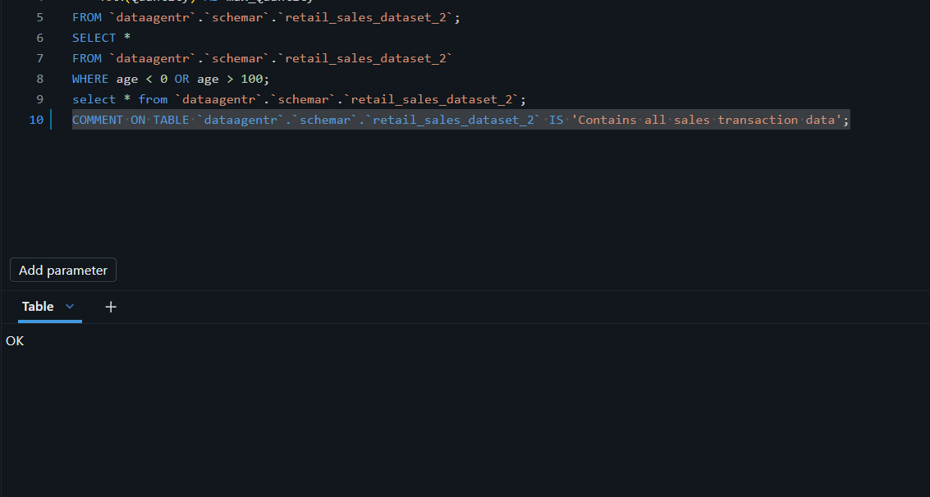

Question 4
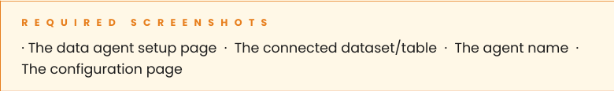

Data agent set up Page
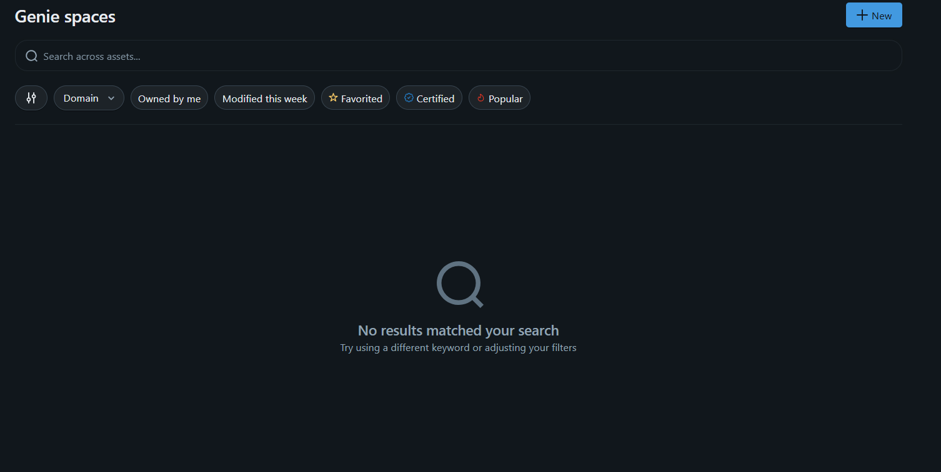

Connected dataset/table
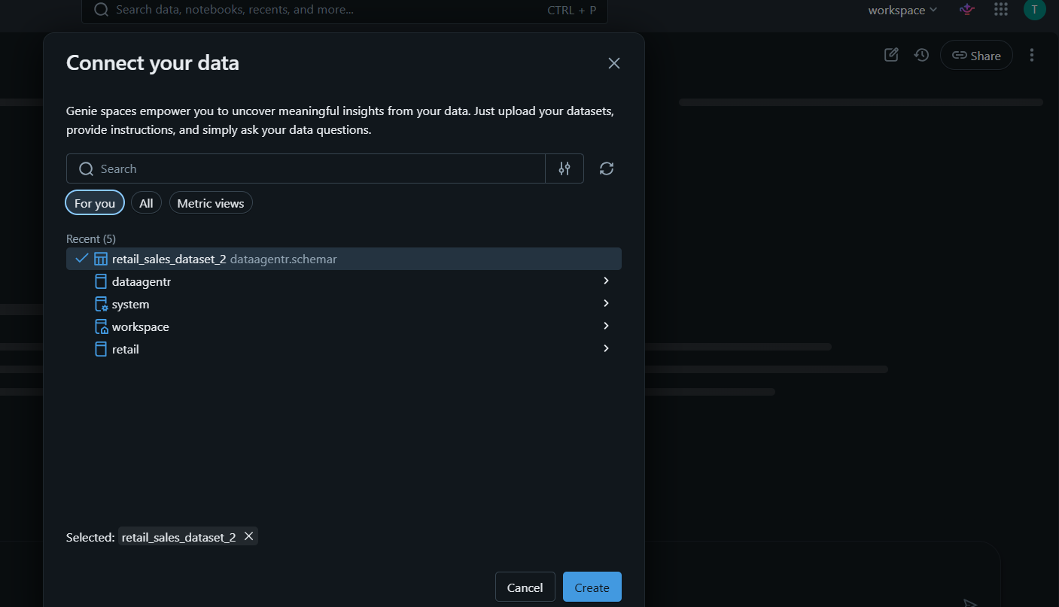

Agent name
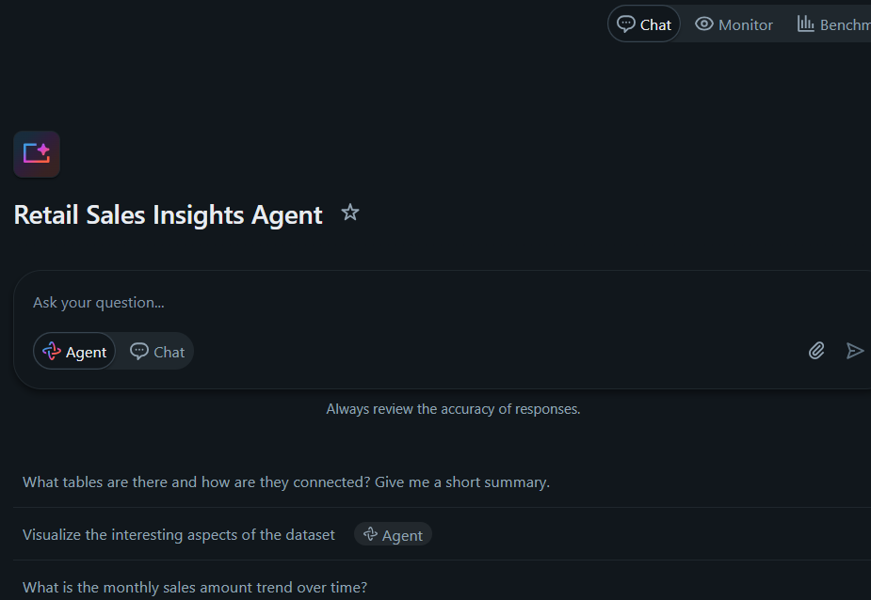
Configuration Page
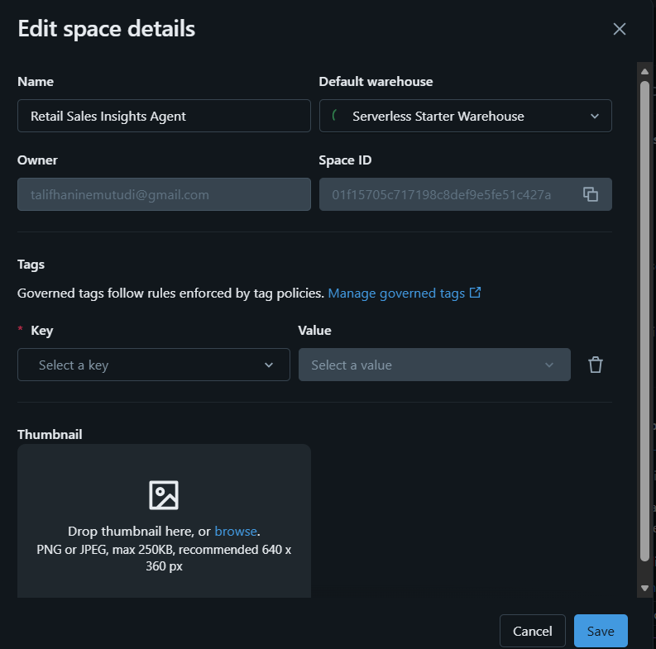

Question 5
Retail sales insights agent role
It enables quick analysis of retail sales transactions to uncover trends, customer insights such as purchasing behaviour, drop in sales, and performance across product categories.it enables the user to have and visualize the data in a matter of minutes while affording them the opportunity to make business decisions in a matter of minutes.
Retail sales insights agent(capabilities)- what it does
- Track sales volume and revenue by date, customer demographics, and product category
- It allows quick data visualization to aid decision making
- Identify top-selling products, customer segments, and sales patterns over time
- Analyse purchase behaviour by gender and age group
- Aggregates total revenue for retail sales
- Provides insight on who exercises their buying power more between men and women
- Which product category is a cash cow for the company, and which is under performing
- Analysis and provides insights on which age group supports the company more
- Monitor transaction-level details for operational performance

For whom the data agent is for- (The users)
- This data agent is for the CEO
- The sales team
- The buying team

Dataset to be used by Retail sales insights agent
- retail_sales_dataset_2
Agent must not edify dataset from any other table, Retail sales agent must use the above dataset only

Question types that Retail sales insights agent should answer
- Sales trends like the highest selling product category
- Data visualization based on the dataset provided
- Age groups trends
- Highest stock level to be sold
- Analysis on Age
- Purchasing power of customers based on sale date
- The distribution (min, max, average, median) of transition total amount

How to explain insights
- A professional tone to be always kept, as these answers are going to be used by stakeholders
- To only use data visualization only when asked by the user
- Answers to be concise theory backed by factual numbers from the data set
- Repetition to be avoided

How to handle ambiguity
- The data Retail sales insights agent must handle ambiguity by clarifying the prompt, breaking it into simple under stable query and ensuring that all expectations are met
- Avoiding repetitions on the Query

How to avoid making things up
- Retail sales insights agent must only use the dataset linked and provided, it should never edify the dataset to meet queries
- If the query needs Retail sales insight agent dataset to fabricate data that’s not on the retail_sales_dataset_2 it must return a null output

How to give recommendations
- Retail sales insights agent can give recommendations only when the question is ambiguous

Full agent instructions

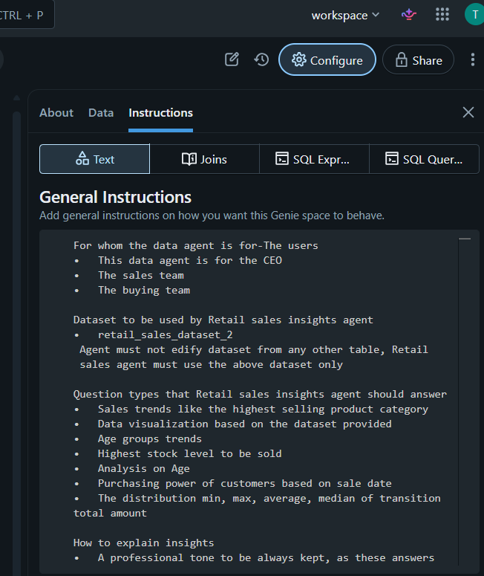

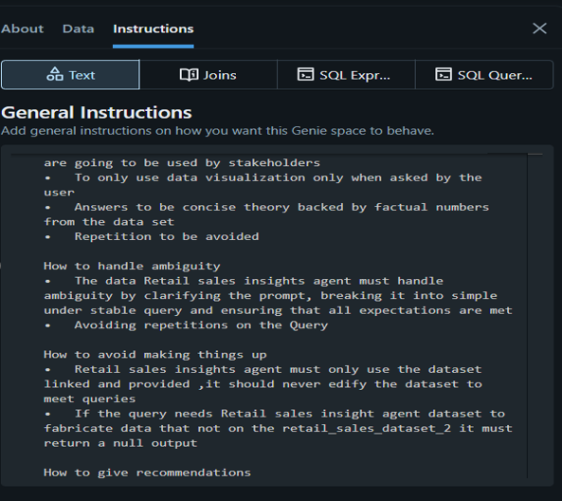

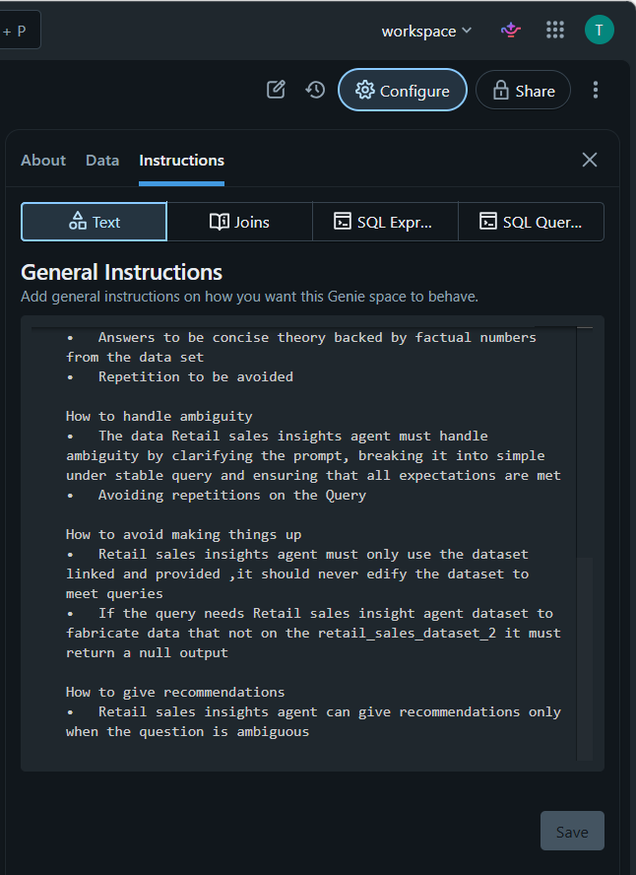

The page where you entered them
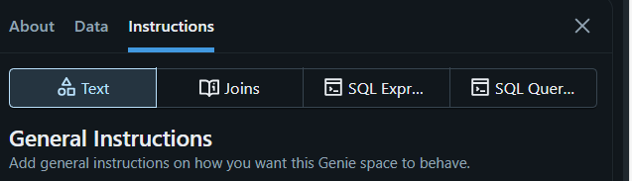

The saved agent configuration confirming the instructions are live

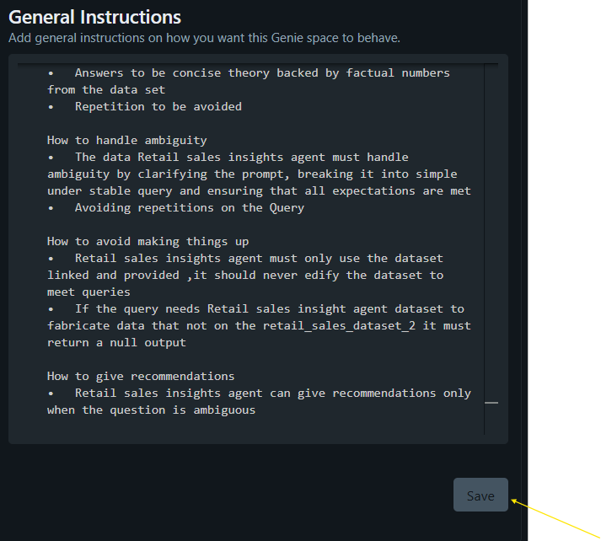
- The Save button is unhighlighted indicating that the instructions are saved and live

Question 6

10 Test questions for Retail sales insights Agent

- Total amount of sales made in Jan 2023

Screenshots
Question
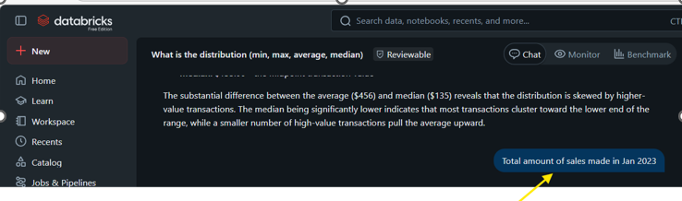
Answer from the Retail sales insights agent
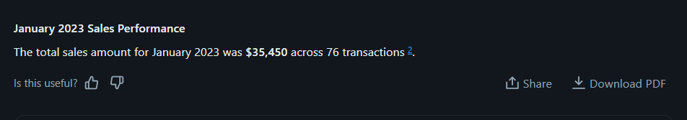

- Total amount made by each product category as a percentage of total amount of sales

Question
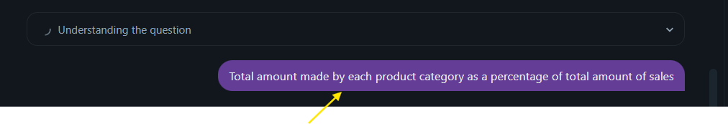
Answer from the Retail sales insights agent
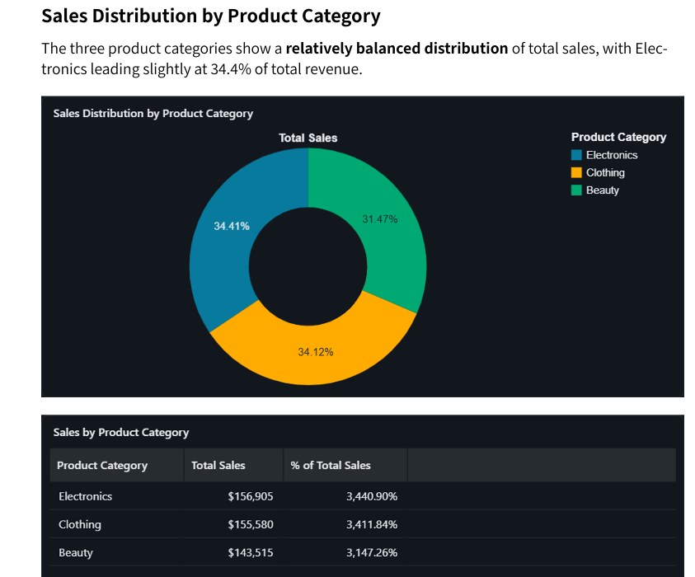
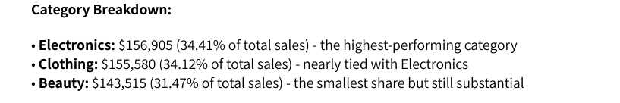
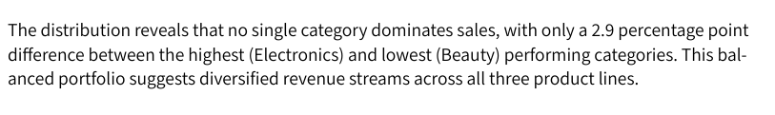
- Create a pie chart of Age categorize by 18-30 Young adult, 30-40 Adult; 40-50 Mid age,51-65 Pensioner
Question
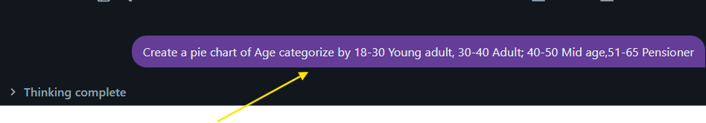
Answer from the Retail sales insights agent
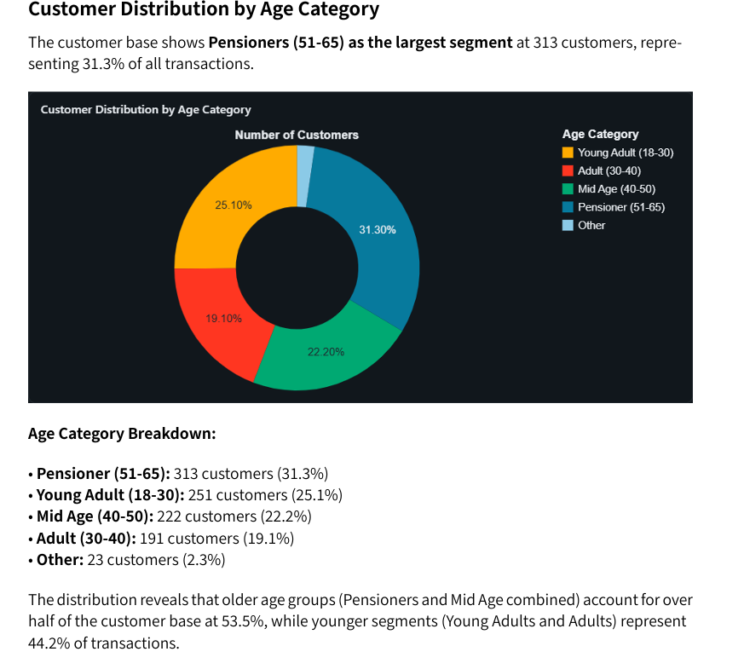
- What is the number of females and what is the number of males on the dataset

Question


Answer from the Retail sales insights agent

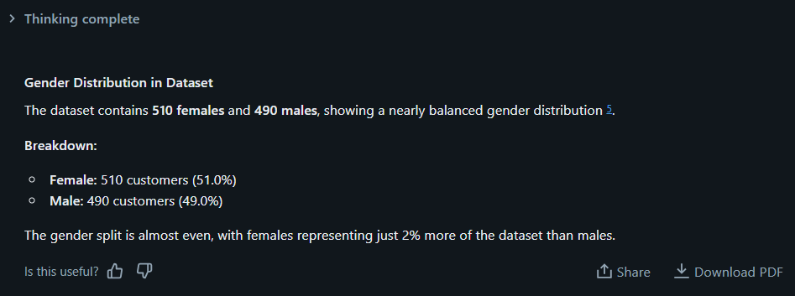

- What are the patterns on total sales for the current financial year end?
Question


Answer from the Retail sales insights agent
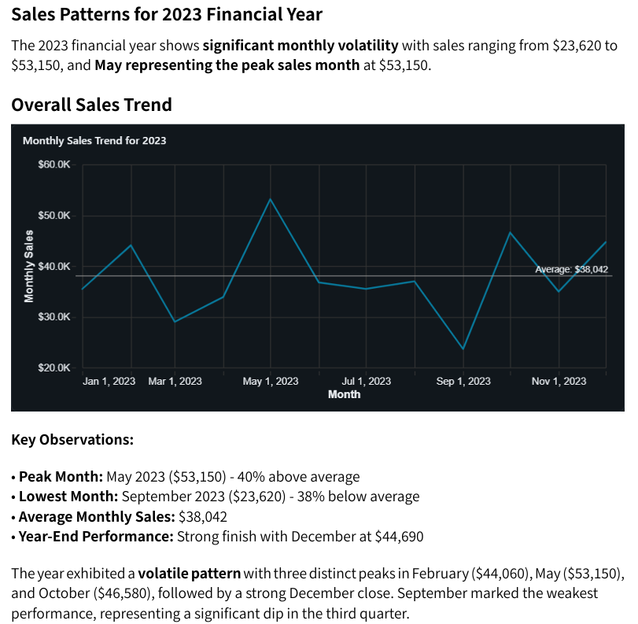
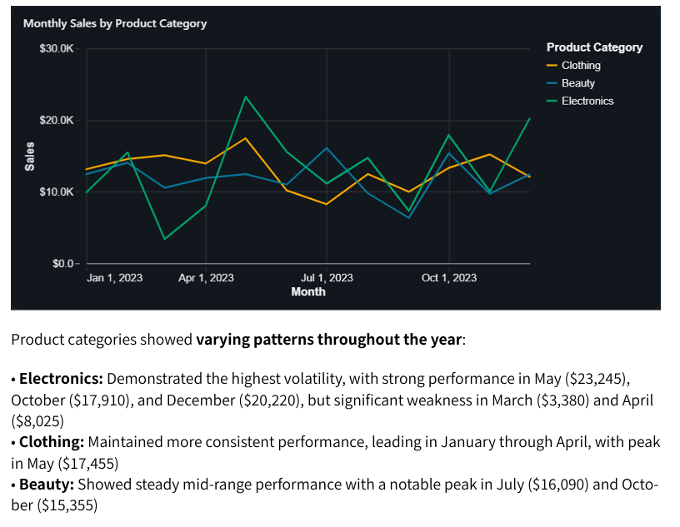
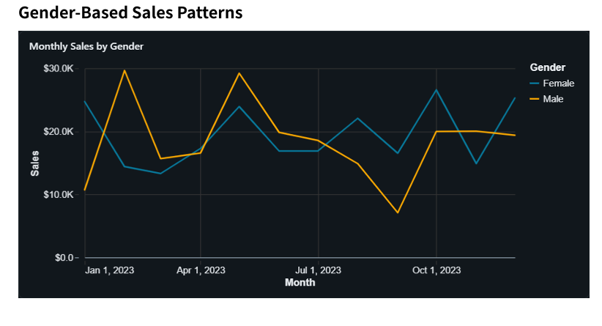
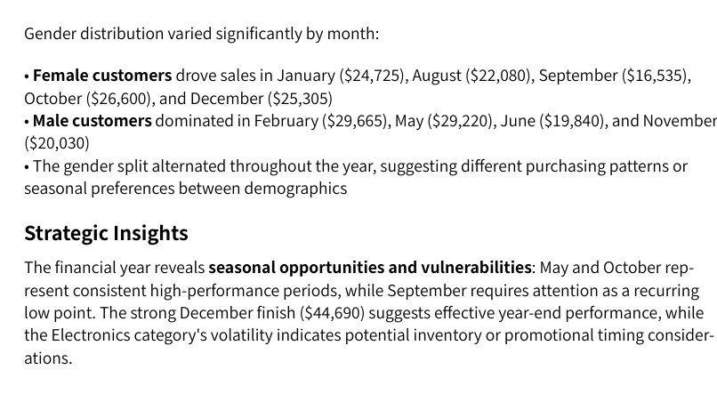
- What is the distribution (min, max, average, median) of the transaction total amounts?
Question

Answer from the Retail sales insights agent
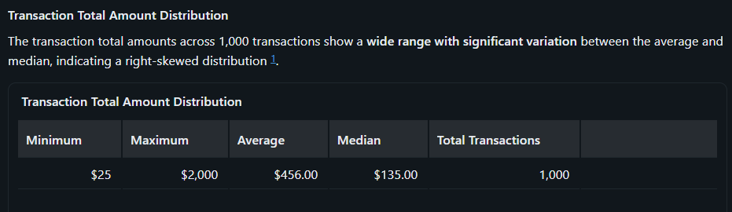
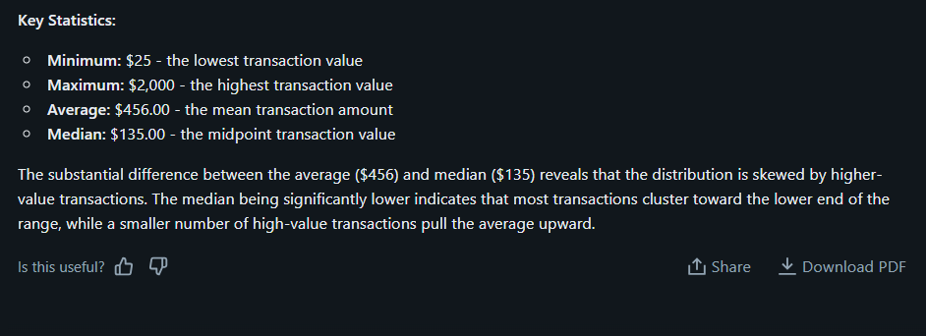
- Do a bar graph of total amount based on product category

Question



Answer from the Retail sales insights agent
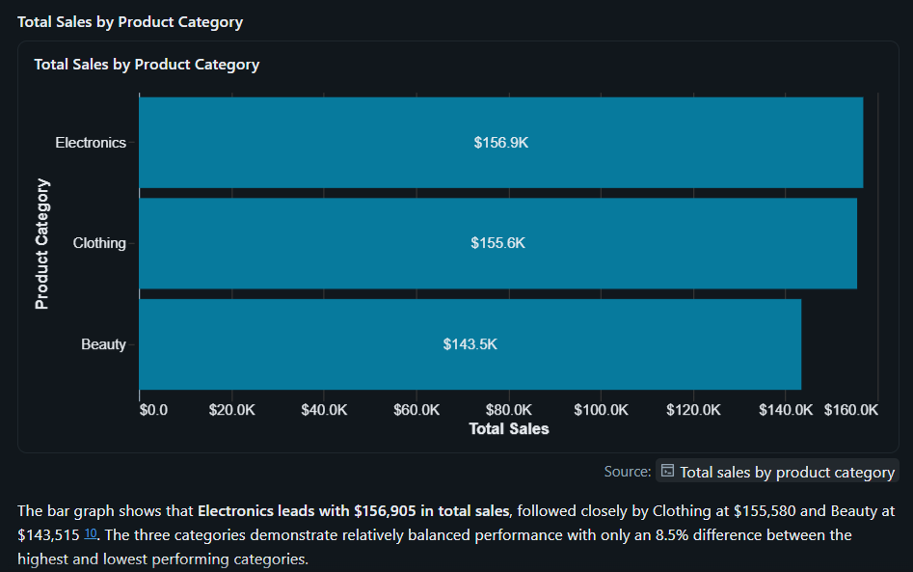

- What is the total quantity of products purchased, categorise by month

Question


Answer from the Retail sales insights agent
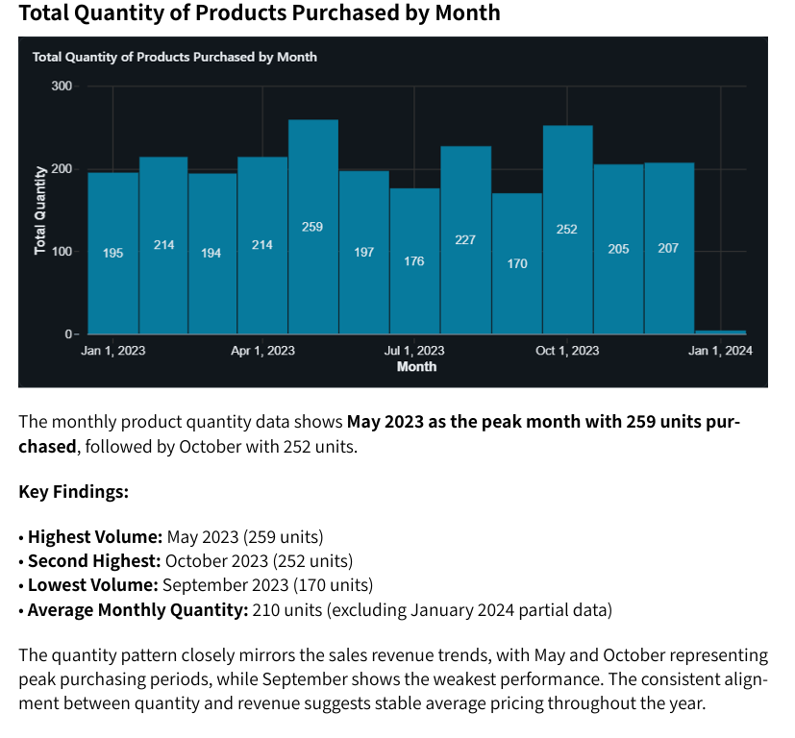

- Total amount greater or equal to 2000

Question
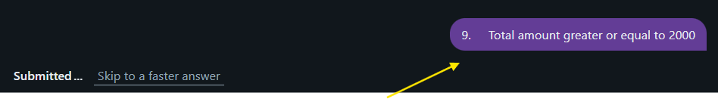

Answer from the Retail sales insights agent

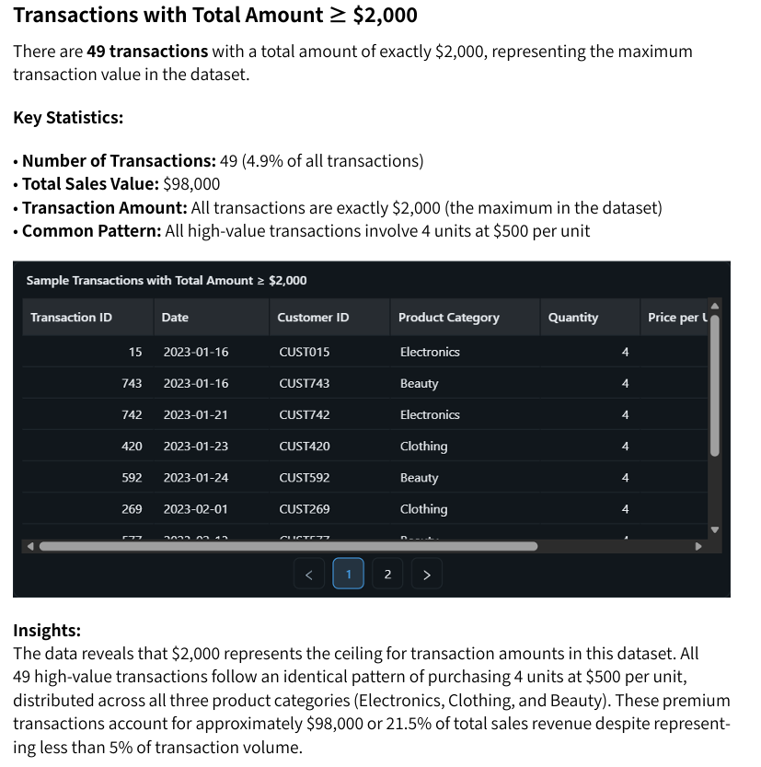

- Based on the total amount, which product is the companies cash cow and what can the company do to increase the sales of its other products.

Question

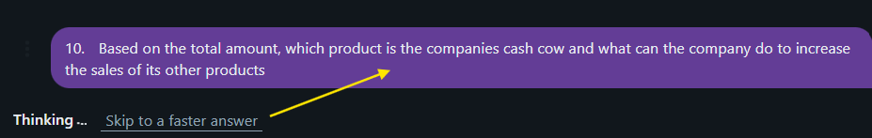

Answer from the Retail sales insights agent
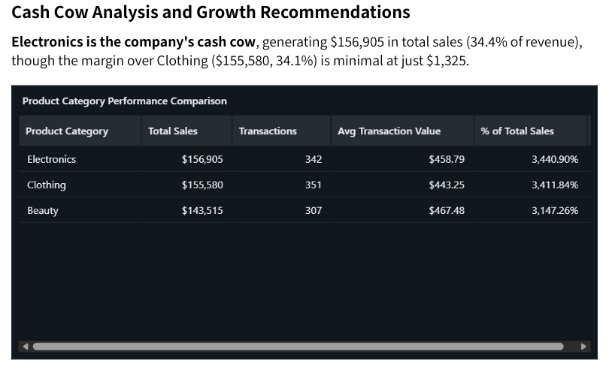
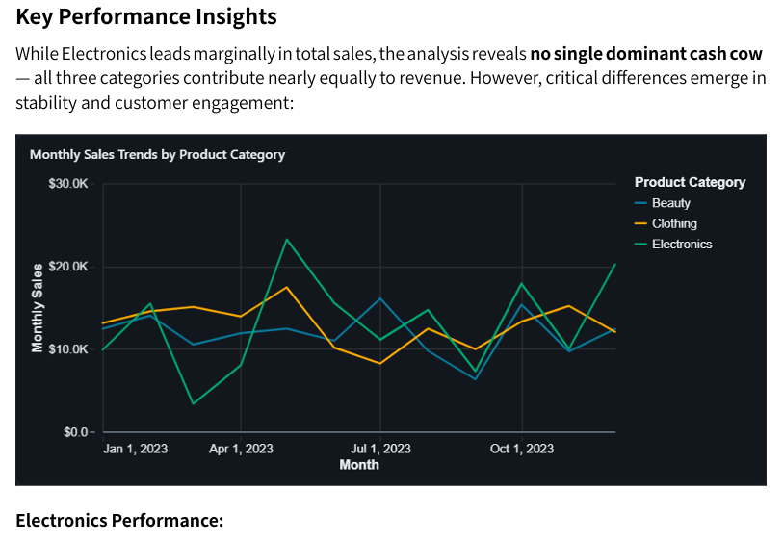
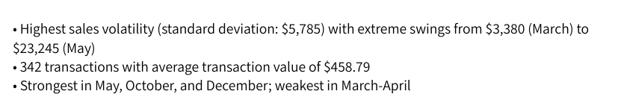

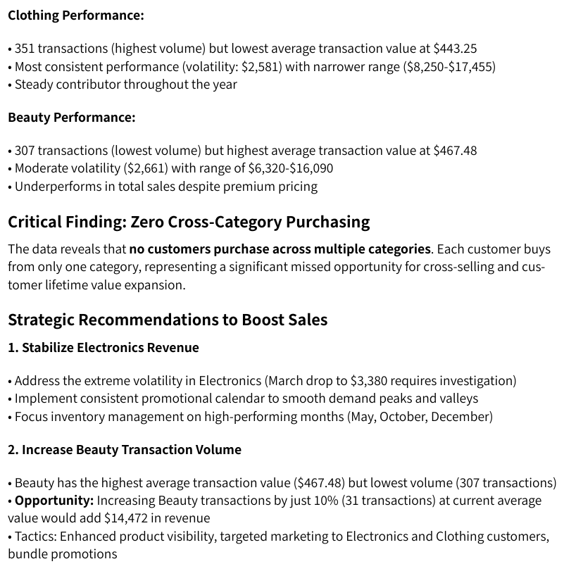
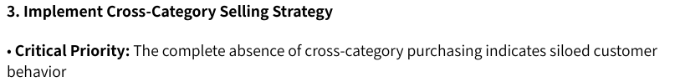
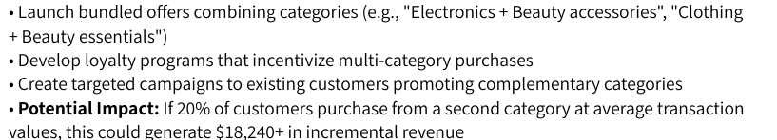

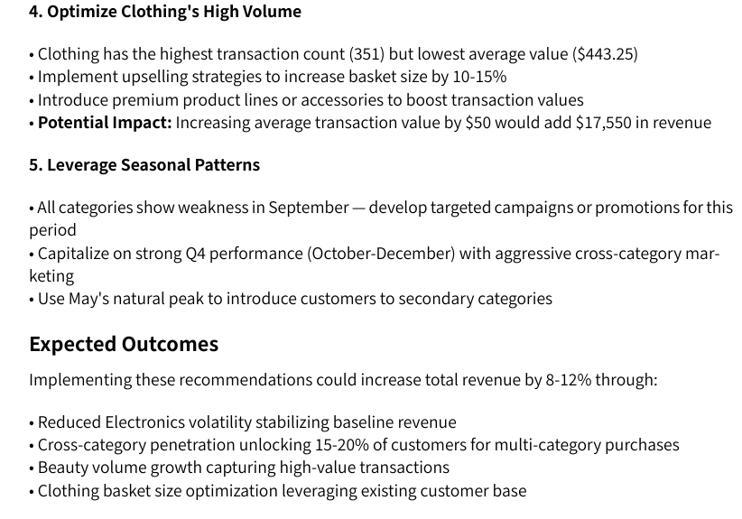
Question 7

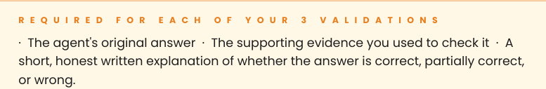

- what is the total amount grouped by product category
Answer from the Retail sales insights agent

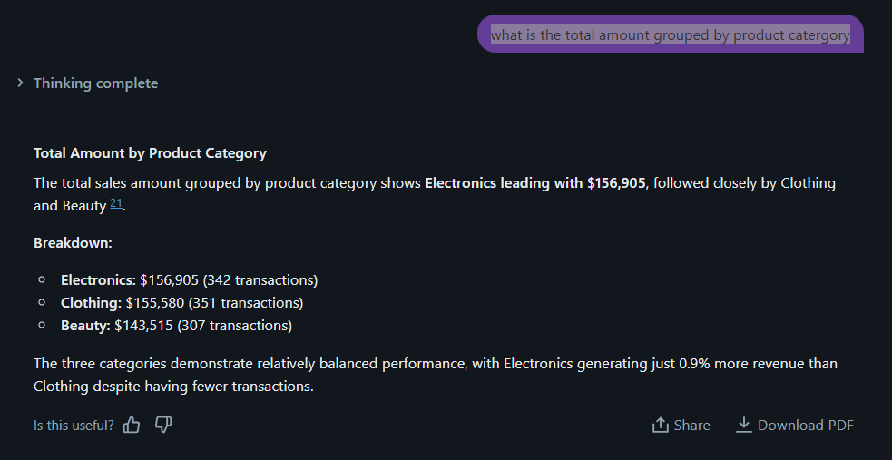
Answer from the source dataset
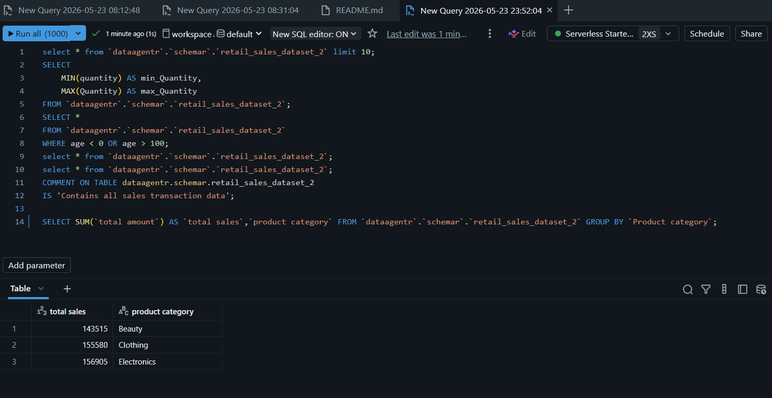

Comment
The answer from the Retail sales insights (data) agent is correct and provides sufficient information to stakeholders that don’t want to analyse and quantify data as it also provides a qualitative explanation as to which product category is making the most money

- What is the distribution (min, max, average) of the transaction total amounts?

Answer from the Retail sales insights agent
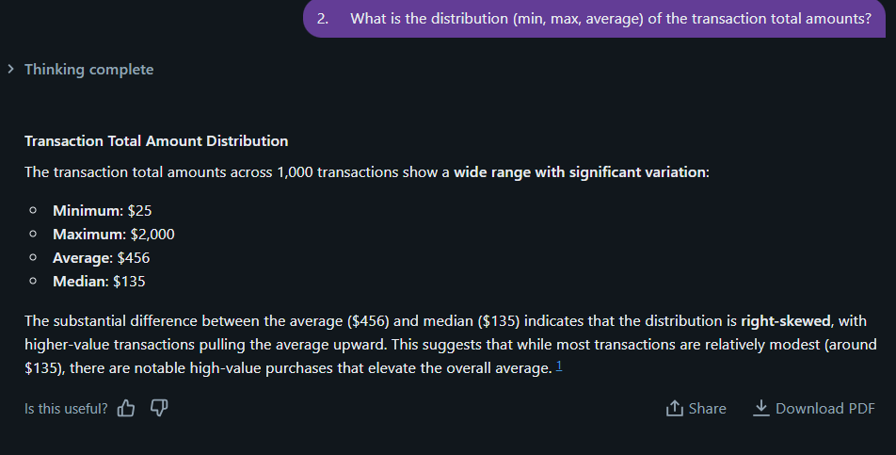

Answer from the source dataset
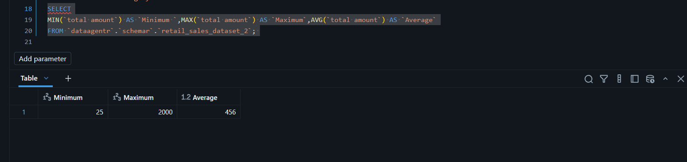
Comment
The answer generated by the Retail Sales Insights (Data) Agent is partially correct, it provides useful explanations of metrics such as minimum, maximum, and average values for the user.

However, the agent also generated responses for questions that were not asked, such as total transactions and median values. This may lead to inaccurate or misleading data visualisation of pie charts and bar graphs, if unnecessary information is incorporated into the analysis.

Additionally, the response contains excessive detail that may not be relevant to the user’s specific request, which can reduce clarity and focus. This might lead to the user not fully trusting the validity of the answers provided by the retail sales insights (data) agent
- Sort the data in Descending order using the total amount limit to 10 rows

Answer from the Retail sales insights agent
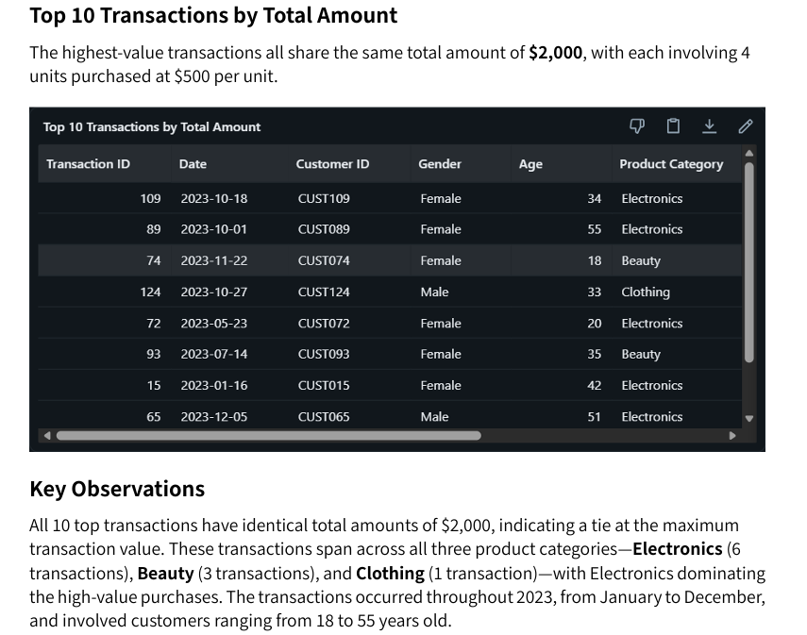
Answer from the source dataset
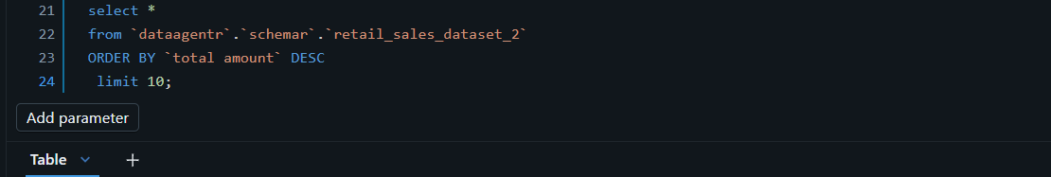
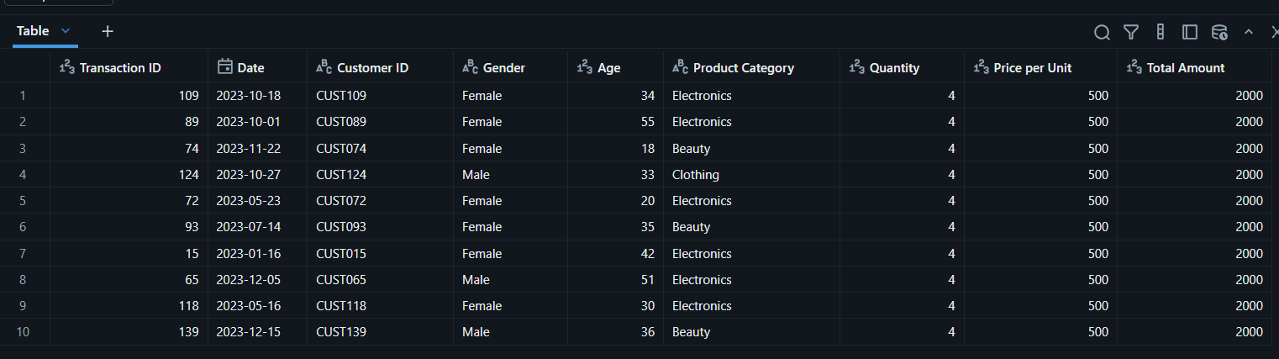

Comment
The answer from the Retail sales insights (data) agent is correct and provides sufficient information to the user and makes it easier as it provides key observations

Key insights
Business Performance Insights

Product Category Performance
- Electronics leads in revenue at $156,905 (34.4% of total), followed closely by Clothing at $155,580 (34.1%) and Beauty at $143,515 (31.5%). Despite similar revenue contributions, Beauty products command the highest average transaction value at $467, suggesting premium positioning.
- This might be due to the fact that 51% of the companies’ customers are female.

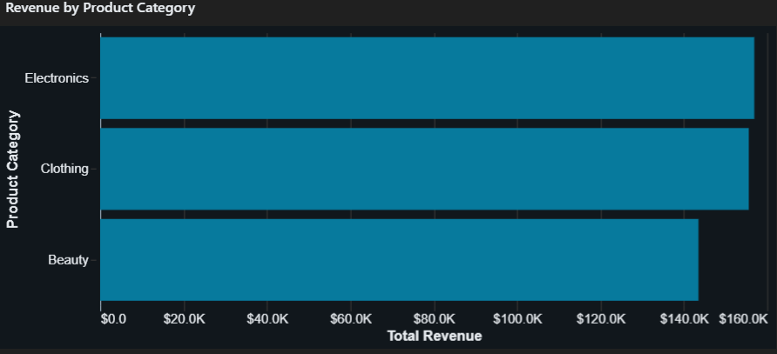

Customer Demographics
- The customer base is evenly split between Female (51%) and Male (49%) customers, with nearly identical average transaction values ($456.55 vs $455.43).
- The average customer age is 41 years, with a range from 18 to 64 years.
- Age group analysis reveals that the 45-54 age group generates the highest absolute revenue at $97,235, but the Under 25 segment shows the highest average transaction value at $501, indicating strong purchasing power among younger customers despite lower transaction volume (149 transactions).

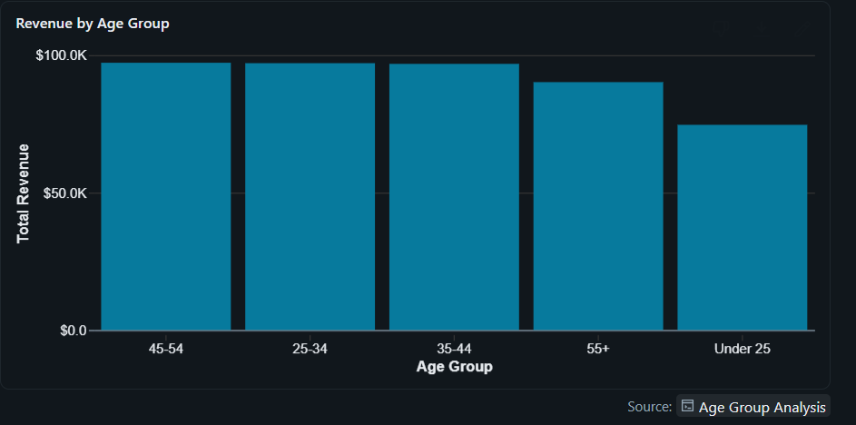
Temporal Patterns
- Monthly revenue shows significant volatility, ranging from $23,620 in September to $53,150 in May 2023.
- The data reveals no clear seasonal pattern, with peaks occurring in February, May, and October. September represents the weakest month, suggesting potential seasonal challenges or operational issues during that period

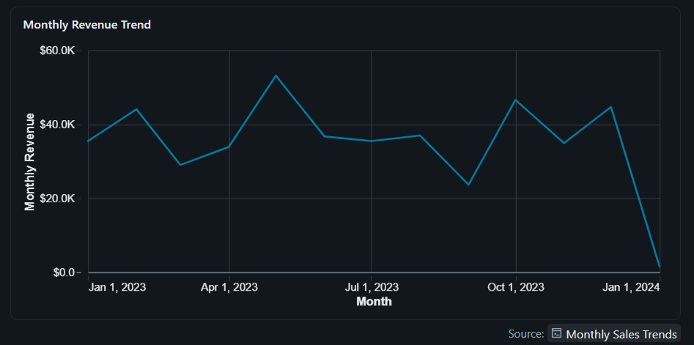

Product category trends over time show Electronics experiencing strong performance in May ($23,245) and December ($20,220), while experiencing a significant dip in March ($3,380). This volatility suggests category-specific seasonal factors or inventory challenges.

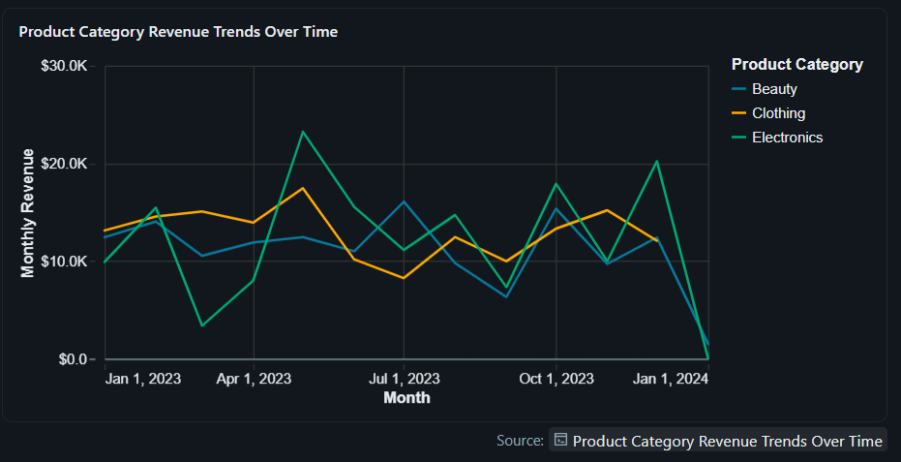

Pricing Structure
The dataset shows a concentrated pricing strategy with five dominant price points: $50 (211 transactions), $25 (210 transactions), $500 (199 transactions), $300 (197 transactions), and $30 (183 transactions). The $500 price point generates the highest revenue at $247,500, representing 54% of total revenue despite only 20% of transactions.

Critical Data Limitations
One-Time Customer Structure: Each customer ID appears exactly once in the dataset, indicating this represents either new customer acquisitions only or a snapshot of single transactions. This prevents analysis of customer lifetime value, repeat purchase behaviour, retention rates, or cohort analysis.
Transaction Value Distribution: The median transaction value of $135 is significantly lower than the mean of $456, indicating a right-skewed distribution with high-value outliers. The maximum transaction of $2,000 is 80x the minimum of $25. 2
Strategic Recommendations

Business recommendations
- Customer retention appears to be low, as the dataset mainly reflects unique customers rather than repeat buyers. To improve retention, the business could introduce loyalty programmes, discounts, or special promotions for returning customers. In addition, implementing customer journey tracking would help capture repeat purchases, allowing the business to measure customer lifetime value and retention metrics more effectively.
- Revenue contribution from both male and female customers is relatively balanced. The business should therefore maintain inclusive marketing strategies while also exploring category-specific preferences. For example, female customers demonstrate a stronger preference for Clothing purchases ($81,275) compared to male customers ($74,305), which could be leveraged through targeted campaigns and product promotions.
- The significant 48% decline in revenue recorded in September compared to the peak in May requires further investigation. The business should analyse factors such as inventory availability, marketing activity, competitor actions, seasonal demand, and operational challenges during this period to identify the root cause of the decline and implement corrective measures.
Conclusion
- What assisted the most is following the notes I took from Leratos consultation
- The suggested answers on the assignment were quite helpful as they provided a guideline for what the desired outcome should be
- Question 2 was the most difficult because Run df.printSchema() and df.describe() are not syntax I’ve come across before

